Accounting Processes and Procedures

Four Creeks Unincorporated Area Council Treasurer
The Four Creeks Unincorporated Area Council (FCUAC) is a Washington State non-profit company recognized by the United State Internal Revenue Service (IRS) as a 501(c)(3) Public Charity.
Summary of key processes and procedures
- Along with satisfying reimbursement requests, paying recurring and non-recurring expenses, reconciling the organization’s books against its bank account, and providing annual financial reporting, FCUAC is required to provide an annual report to the WA Secretary of State, and file Form 990-N to the IRS.
- FCUAC UBI: 601937163; FCUAC EIN: 30-0316151
- If FCUAC pays any person more than $600 annually to provide services to the organization, FCUAC is also required to send that person IRS Form 1099-MISC, and file Form 1096 to the IRS, along with copies of the 1099-MISCs. (See note about filing 1099-MISC forms electronically.)
- The FCUAC books are in an Excel workbook. Documentation of the methods and rules for bookkeeping are in a separate document (FCUAC Bookkeeping Methods and Rules)
- FCUAC has one bank account, with multiple officers having signature authority (i.e. can sign checks).
- Each of the officers with bank signature authority also have a debit card that they can use for financial transactions. Any use of those debit cards must be reported to the FCUAC treasurer either before the use, or within a day or two of the use. In addition, any fraudulent use, along with a lost or stolen debit card must be reported by the card holder to the bank and the treasurer immediately.
The FCUAC Accounting Processes and Procedures is an official document of the FCUAC Treasurer.
It includes:
- The master calendar
- Reporting requirements (federal and state)
- Bookkeeping
- Bank account

Master Calendar
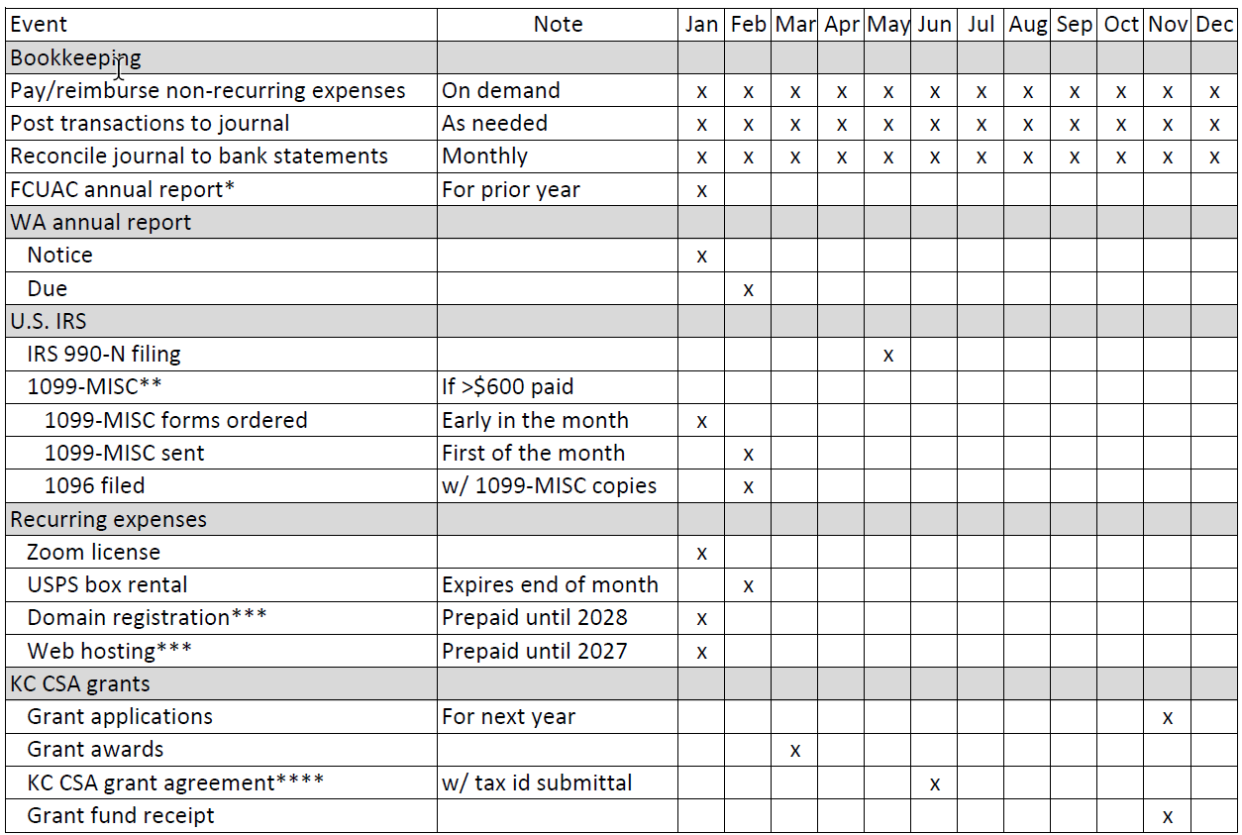This master schedule image is in a separate Excel spreadsheet (FCUAC Accounting Master Schedule). It includes some additional explanations of some of the items.

Events
The major events on the FCUAC calendar are the FCUAC annual report (cash flow, balances), the annual report to the WA Secretary of State, and tax reporting to the U.S. Internal Revenue Service (IRS), which includes filing form 990-N and, if any person was paid more than $600 in the previous year, printing/mailing of IRS Form 1099-MISC to those persons followed by the submission of Form 1096, with copies of the 1099-MISCs, to the IRS.
In addition, recurring (PO box, Zoom license, web hosting and domain registration) and non-recurring expenses are paid directly, or via reimbursements to individuals who paid those expenses.
Finally, although not necessarily submitted by the treasurer, grant requests are submitted and, if approved, a grant agreement sent by the county needs to be returned, and the grant revenues are received and deposited.
Frequency | Date | Description
Monthly |  | Download bank statements; reconcile checking; update books/reports
Annual | By January FCUAC meeting | Prepare/deliver year-end financial statement
Annual | Sent to payees by February 1 | Order 1099 Misc IRS forms early January if needed; print/mail 1099-Misc IRS form to any non-employee paid over $600 during previous year
Annual | Approximately 3 February | Received notice of requirement to provide annual WA State Business License report
Annual | 19 February | Submit annual WA State Business License report
Annual | By the last day of February | Print/file 1096 (along with copies of any 1099-Misc forms) to IRS if any 1099-Misc forms were sent
Annual | By the last day of February | Pay annual Post Office box rental.
Annual | By May 15; but at least once in 3 years | eFile 990-N (ePostcard) Federal Tax Return
On demand |  | Pay reimbursement requests  Pay invoices (e.g. web hosting)  Receive funds (e.g. grants, donations)

Reporting Requirements

Unified Business Identifier (UBI) and Employer Identification Number (EIN)
- The FCUAC UBI is 601937163
- The FCUAC EIN is 30-0316151

WA State business license
- The WA State Secretary of State (SOS) requires companies with WA State business license to provide an annual report.
- Currently, the annual filing charge for non-profits is $60, however, organizations with less than $500,000 in revenue in the tax year can certify that fact on the form, which reduces the charge to $20. The certification is done on the annual report form.
- The annual report form can be downloaded, filled out, and mailed to the WA SOS. There is also a fillable PDF version of the form. In addition, there is the Washington Corporations and Charities Filing System (CCFS) which allows corporations to create an online account from which they can file returns, among other things.

U.S. Internal Revenue Service (IRS)

990-N
- As a 501(c)(3) charitable organization FCUAC is required to annually file IRS Form 990, or one of its variants, which provides the public with financial information about non-profit organizations. It is also used by government organizations to prevent organizations from abusing their tax-exempt status.
990-N: look online
Sign in with active IRS user name
3/4/23 setting up new account
    - FCUAC electronically files the variant form 990-N, also known as an “e-postcard”, which is for non-profits with annual income normally less than $50,000.
- Currently, income reporting is due to the IRS by the 15th of the fifth (5) month past the end of the organization’s fiscal year
    - FCUAC ends is fiscal year on December 31st
    - Therefore, the due date for IRS reporting is May 15th
Note: Screen shots of the IRS form 990-N, along with shots of the 990-N submittal confirmation from 2016, are included at the end of this document.

1099-MISC and 1096
Payments in excess of $600 annually made to outside parties by FCUAC are subject to 1099-MISC reporting. FCUAC must send IRS Form 1099-MISC to any of these parties, and then submit Form 1096 to the IRS along with copies of any 1099-MISC forms sent to outside parties.
- Order 1099-MISC forms early in January.
- The 1099-MISC form is downloaded, converted to Word, and used to send 1099-MISC to payees.
- 1099-MISC must be sent to payees by January 31st.
- NOTE that the SSN of the payee is completely entered on the IRS form. Much of it is blocked out with asterisks (***) on the form that goes to the payee.
- FCUAC submits copies of the multi-part Form 1099-MISC to the IRS is submitted to the IRS when FCUAC files Form 1096.
- Note that there is an option to submit Form 1099-MISC to the IRS electronically. When submitted that way, not Form 1096 is required. Look into filing 1099-MISC forms electronically the next time FCUAC pays an outside party a sufficient amount to require sending 1099-MISC forms.

Bookkeeping

Books
- FCUAC maintains financial transaction data in an Excel spreadsheet.
- Instructions on its use are in a separate document: FCUAC Bookkeeping Methods and Rules.

Bank Account and Debit Card

Checking Account

Signature Authority
- The bank where FCUAC maintains its checking account requires a copy of the meeting minutes when the FCUAC board authorizes an individual to have signature authority on the account as evidence of that decision. For example, the minutes of the meeting when a new treasurer is appointed can be presented to the bank to authorize the new treasurer to have signature authority for the bank account.

Debit Cards
- A debit card associated with the checking account can be used to charge directly against the FCUAC checking account.
Currently, FCUAC has issued debit cards to the officers who have signature authority for checks.
- Updates to the debit card information, where used, are required when:
    - The card number changes
    - The card expires
    - The name on the card is changed (i.e. when a new individuals with checking signature authority are added.)
- When debit cards are used, the user must notify the treasurer either before, or within a few days after, the use of the card.
    - That notification includes the name of the business or person receiving the debit payment, and the purpose of the payment.
- Authorized debit card holders must report any fraudulent use of the debit card, or if the debit card is lost or stolen immediately to the treasurer and the bank.

Direct charges against the bank account
- The treasurer may authorize direct charges to the FCUAC checking account. One current example is GoDaddy, who is authorized to electronically withdraw money from the account for web domain and hosting services.

990-N example and submittal confirmation

990-N example copied from IRS web site 2/11/17
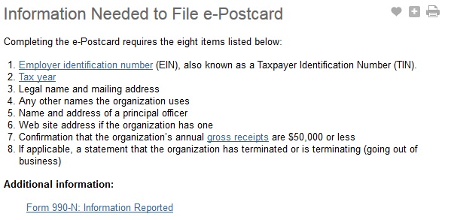

990-N submittal confirmation example (2016 tax year)
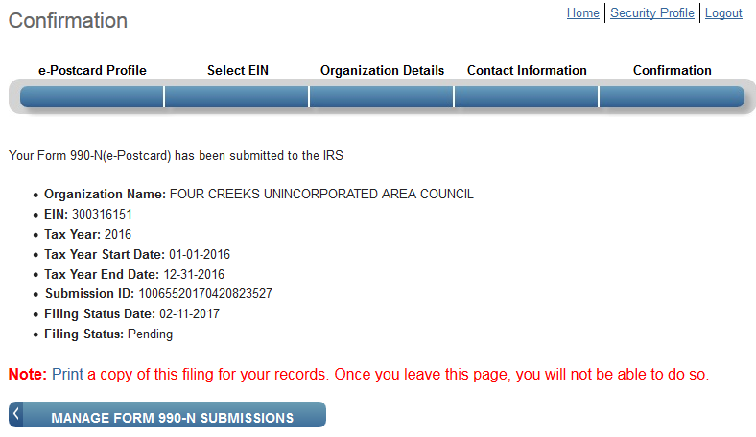

990-N (ePostcard)

