Tiger Mountain family nudist park
A Scenario 7.2 Earthquake
As It Applies to Tiger Mountain Family Nudist Park
Tom Kintner
10/15/2019

This report is a “best guess” at the effects of a 7.2 magnitude earthquake on the Seattle Fault Zone, and how it may affect the park. It also identifies some of the mitigation efforts that need to be done by the park and its residents. There is no doubt the event will happen, but when it will happen cannot be predicted.

Introduction: How to use the attached report

1. Read the report; review it with others in your household, friends, and relatives, understanding that this is, at best, a genuine guess at what may happen, sometime in the next 50 years. The last major Seattle Fault Zone quake was 900 AD, over a thousand years ago. There is no way to predict the next one.
2. Since we regularly have other emergencies in the area, power outages, snow and windstorms, fires, etc, this should be motivation to prepare your household for two weeks (at least) preparedness, and more, if you can afford it. See www.Ready.gov online.
3. Additional preparation could include:
a. Training as a neighborhood Emergency Readiness Team member, sometimes called Community Emergency Response Team (CERT), or Neighborhood Emergency Team (NET), and other names.
b. Participate in meetings with your neighborhood members to Map Your Neighborhood, a program that will help neighbors be part of the solution for the preparedness challenge.
c. Completing FEMA online courses to prepare you for handling or participating in emergency response.
d. Reading Prepared Neighborhoods, https://preparedneighborhoods.com/ by Scott James, available on line. Mr. James is passionate about the neighborhood being a team for preparedness and sustainability.

Scenario, as it applies to TMFNP (From: EERI and WAEMD, Scenario for a Magnitude 6.7 Earthquake on the Seattle Fault, June, 2005, accessed 8/28/2019: https://www.eeri.org/wp-content/uploads/2011/05/seattscen_full_book.pdf , and Modeling a Magnitude 7.2 Earthquake on the
Seattle Fault Zone in Central Puget Sound,2012-2013, accessed 9/11/2019, attached as Appendix A)

The Scenario Earthquake

A major earthquake on the Seattle Fault will have a significant impact on the communities of the Central Puget Sound region. The magnitude 7.2 (Estimated Intensity of VIII to IX) scenario earthquake and its aftermath will disrupt for weeks and months individuals, families, businesses and governments throughout the region. The disruption will be much, much greater than the February 2001 magnitude 6.8 Nisqually earthquake, and will have a substantially greater impact than an earthquake generated by the Cascadia Subduction Zone, because it is much nearer to our area, and located virtually on the surface (less than 10 mile depth).
One of the region’s major fault zones is the Seattle Fault Zone. It runs from Hood Canal in the west, through Puget Sound and south Seattle, and east through Bellevue and Issaquah, roughly parallel to Interstate 90. An earthquake on the Seattle Fault of magnitude 7 or greater about 1,100 years ago generated a tsunami in Puget Sound, landslides in Lake Washington and Lake Sammamish, rockslides on nearby mountains, and a 22 foot uplift of a marine terrace on Bainbridge Island. A strand runs through May Valley, west from Newcastle, through Renton, and east to 15 Mile Creek beyond the Issaquah-Hobart Road.
Among the biggest concerns facing the region immediately after the earthquake are that:
■ Police, fire, and medical aid units will be overwhelmed in the initial hours after the earthquake.
■ Damage to transportation systems will make movement of people and freight around the region difficult for weeks or months.
■ Demand for emergency shelter, food and water by displaced individuals and stranded commuters will place tremendous demand on available community resources.
■ Disruptions to transportation, telecommunications and utility systems, and damage to key facilities, will complicate the daunting task of getting the region – and the state’s – economy back on its feet.
■ Significant ground failures – including fault rupture, liquefaction and landslides – will occur throughout the region and contribute greatly to building damage.
■ Outages of electricity, water, waste water collection and treatment, natural gas and liquid fuels, and communications will last from days to weeks depending upon a variety of factors including location of facilities to the fault rupture, ground shaking, and soil strength.
■ Modern structures built on firm soils will survive with various degrees of damage in the scenario earthquake. Unretrofitted, older structures will sustain heavy damage. Of particular concern are unreinforced masonry and reinforced concrete tilt-up structures, which have performed poorly in past earthquakes and are common in the Central Puget Sound region. The most extensive damage will be along the Seattle Fault rupture and along low-lying river valleys with liquefiable soils.
■Most people are involved in activities outside their home – working, at school, shopping, for example – and are more likely to be in buildings that do not perform as well as their wood-frame residential structures.

Limitations of the Scenario

The Seattle Fault Earthquake Scenario has limitations, as major studies typically do. The three major issues that this scenario document does not explicitly address are aftershocks, the generation of a tsunami or seiches, and fires.
Aftershocks for the scenario earthquake will likely include several magnitude 7.0 or greater. Thousands of aftershocks would be expected.
Large earthquakes can generate tsunamis, damaging waves that result from movement in the water column caused by deformation of the sea floor or lakebed. Earthquakes also cause seiches, waves in an enclosed or partially enclosed body of water that are similar to violent sloshing in a bathtub.
The scenario earthquake most certainly would generate damaging seiches in bodies of water throughout the study region. Like tsunamis, seiches threaten people and structures such as homes, marinas, bridges and structures on or near shorelines.
Fire represents a serious post-earthquake hazard. Broken infrastructure, such as natural gas lines, will supply fuel to get raging fires started, and earthquake damage to the transportation system will prevent emergency vehicles arriving to fight those fires. Broken water mains will also drain the water with which to fight those fires.

Discussions:

Ground Failure

Three types of ground failure will occur during the M7.2 scenario earthquake including:
■ Surface fault rupture.
■ Liquefaction-induced ground failure.
■ Seismically induced landslides.

Surface fault rupture in the Seattle Fault Zone is difficult to predict, primarily because the exact locations of the fault traces are not well-defined. Based on previous aeromagnetic, gravity, offshore seismic reflection, limited fault trenching, and LIDAR data, scientists have developed at least three possible models for faulting in the Seattle Fault Zone. Since the park is located upon Tiger Mountain, it is not expected to have a rupture: 1) because we are on an integral unit (bedrock), and 2) the measured fault strands, while running east-west, are located well north of the park, running through Issaquah at I-90, and somewhat south of the park, running just south of the May Valley intersection with Issaquah-Hobart Road. Shaking, while intense, will most likely shake the mountain as a unit.
Liquefaction occurs when soil grains in loose, saturated, silty, sandy, or gravelly soils attempt to rearrange themselves in a denser configuration when subjected to strong earthquake ground motions. The resulting increase in pressure of the water in the voids of the soil temporarily transforms the soil into a fluid, causing the soil to lose much of its strength. While problematic in May Valley and the Issaquah Creek Valley, it does not appear to be a problem on Tiger Mountain. Ground saturation occurs late October through the following May, during our rainy/snowy season. Not yet studied: Potential liquefaction within the park roads and culverts.
Seismically induced landslides: Based on current knowledge of landslides in the Puget Sound area and theoretical studies, the severity of seismically induced landslides and related damage is dependent on the level of ground shaking and groundwater conditions at the time of the earthquake. According to the Washington Department of Natural Resources (WADNR) landslide inventory, this area of Tiger Mountain has had no landslides of geologic or historical record, and the conditions promoting landslides do not apparently exist here. Not yet studied: Potential landslides on or near the road and culverts, and fill near the pools, which may be problematic.

Lifelines

Lifelines are the often unseen network of public and private services and structures in a community that form the foundation of its development and are necessary for its well-being and economic vitality. Lifelines include water, sewer, natural gas and liquid fuel, electric power, and telecommunications systems. Without one or more of these lifelines, it becomes difficult for a community to function well.
This chapter addresses how the scenario M7.2 earthquake will affect the following five lifelines.
■ Water
■ Wastewater
■ Electrical Power
■ Communications
■ Natural Gas and Liquid Fuels
Water is supplied via our well, and stored in two 2,500 gallon cisterns, located near the northeastern border of the property. The well is 305 feet deep, and draws from the aquifer in Tiger Mountain. We have had instances in the past where the recharge rate, the time it takes to fill the cisterns, has been extended because of the lowered availability of the well water. This is the reason we use the sump near the lower bathroom to water the lawn from June through September.
It is common for well levels to fluctuate, related to precipitation volume and also to earthquakes, even distant ones. We have no experience that would give us an idea of how our well will react to an earthquake.

Mitigation Strategy: Ensure water remains available during an outage by providing an alternative source of water: store water, provide greater capacity in cisterns, install alternative well source, and add storage capacity to living facilities.
Mitigation: 1. Install a ~200 gallon tank at each residence, fed from the water system to the residence. This will allow an additional storage of 2,000 gallons of water in the system, and provide “bridging” of water interruptions for each household for 40 person-days (one day of water per person for 40 days, or 2 people for 20 days, etc.).
2. Add capacity to the water system by adding 10,000 or more gallons storage.
3. Add a 100,000 gallon pond near the northern border of the park, fed by springs, and giving fire fighting water as well as emergency water.
4. Determine the water table, and purchase an emergency well, operated by hand power for individual needs, perhaps near the kitchen.

Wastewater is gravity fed to our septic tanks located below the volleyball court, and then electrically pumped up to the drain field just west and uphill from the Maintenance shed. The older drain field, which is gravity fed, is currently disconnected from the septic system, and may have been damaged as a result of the 2017 logging. Should the older drain field be reconnected and permitted, the septic system will be entirely gravity fed, and will not have any need for electricity.

Mitigation Strategy: Provide alternative to the existing electrical pumping of septic.
Mitigation: 1. Revive the older, gravity fed drain field for emergency and off-season use.
2. Install composting toilets.

Electrical Power is supplied by Puget Sound Energy (PSE) via SE 127th Street from Issaquah-Hobart Road, and connects both park and private facilities. Chances are virtually 100% that power will be lost as a result of the scenario earthquake, and restoration could take from one to many months, especially considering where on the priority list our tail circuit may be (very low).

Mitigation Strategy: Become independent from the commercial power source, and supply our own power by adding solar, wind, and hydro power generation.
Mitigation: 1. Use existing roofs for solar power.
2. Consider erecting a wind generator.
3. Determine power capacity available from hydro and install it.

Communications is supported by several systems, the oldest of which is the Century Link wire line, our basic telephone for the park, the front gate, and the emergency pool telephone. This has unusually high reliability during earthquakes. It depends on power supplied via the telephone line from a central office. Other, and substantially unreliable systems, provide the internet and cellular phone service, both of which are dependent on available electrical power, and will be overloaded shortly after an event as customers attempt to reach loved ones to find out how they are, or to let them know that the caller is or is not OK, and why. Parenthetically, texting can often get through when cell calls can’t, because they use a different method of transmission not dependent on the cellular phone protocols.
The above are two-way communications. One way communications comes from broadcast television (cable, over the air, or via the internet), and local commercial radio stations. Cable is especially dependent on power availability and so will probably not be operational for the end user until well after power returns to the park. The same is true also for broadcast television, even though they may operate on generator power for a while.
Commercial Radio stations who opt to support emergency communications with the FCC will remain on the air (or return to the air) and provide news and public notices.
Finally, a communications system less dependent on outside infrastructure is Ham Radio. There are at least two operators resident in the park. Ham (Amateur) Radio is part of the planning for post event communications, known as Amateur Radio Emergency Service (ARES).

Mitigation Strategy: Identify and install alternative communications.
Mitigation: Not yet specified.

Natural Gas and Liquid Fuels include the propane that heats the water for the pools and the showers, the gasoline that fuels the lawnmowers, and the diesel that fuels the tractor. Natural gas is not used here. Earthquakes frequently break lines, leaving the propane exposed to ignition sources, and resulting in fires fed by the broken lines.
In addition Williams Pipeline maintains the natural gas line crossing our SE 127th road near the Issaquah-Hobart Road intersection. The welded-steel pipelines are in competent soils along most of their route through the region. The pipeline alignment is at the eastern edge of the expected fault rupture. If limited fault displacement occurs, the pipeline should perform well.

Mitigation Strategy: Prevent the discharge of uncontrolled fuels, thereby greatly reducing if not preventing the incidence of fires.
Mitigation: 1) Install earthquake sensitive automatic shut off valves on the propane tanks in the park.
2) Keep stored fuels locked in storage areas to prevent release or spillage of gas and diesel fuels.
3) Keep personal fuels stored in an earthquake safe manner, and outside and away from homes.

The Regional Transportation System

The Central Puget Sound region’s transportation system is an integral set of networks and routes connecting many locations and providing for the movement of people and products within, into, and out of the region. Highways and secondary routes allow people to commute to and from work and move people and goods to ferries, rail stations and yards, airports, and seaports. Local water ports rely upon shore-side facilities, highways, and rail to move supplies and goods in containers from ships to regional manufacturers and retailers and to end users a continent away. Seattle-Tacoma International Airport provides access to air travel to support regional, national, and international business, and both Sea-Tac and Boeing Field provide for overnight delivery of critical business documents and shipping of cargo around the world; highways and secondary routes move people and goods to and from the airports.
The region’s economic well-being relies upon the smooth interconnections of its highways, ferry and rail systems, and air and water ports. A major disruption to any one of these components, such as will be caused by the scenario M6.7 earthquake, will overload the other systems, reducing their efficiency, potentially bringing them to a halt, with devastating effect on the region’s economy.
Immediately after the earthquake, there will be massive congestion as bridges fail and the region’s primary transportation arteries – its Interstate freeways and state highways – become saturated with traffic. Significant delays will occur. As witnessed after the Loma Prieta, Northridge and Kobe earthquakes, adaptive transportation routes and modes will emerge within the first few days after the scenario event. Use of secondary roadways and accessible waterways will increase. Transportation system inefficiencies will last from months to years; the length of time depends how long it takes to make repairs. [Scenario, pp 63-65].
Depending on where one experiences the scenario earthquake, if you are not home, you may find it difficult if not impossible to get home or other place of refuge within a few days.
Specific to the park is the access road. This road is the one access to and from the park. Should the road fail, only foot traffic will be able to negotiate the access to the park until repairs can be completed. The culvert over Nudist Creek will most likely fail due to the earthquake, making access impossible until repaired or replaced. The remainder of the road is cut into the hillside, offering additional opportunities for landslide damage. Parenthetically, the potential to fight fires is also compromised by the single point of failure. The upper culvert, just outside the gate, is similarly vulnerable, and will likely fail in the scenario earthquake.

Mitigation Strategy: Provide alternatives to access the park, bypassing the current access road.
Mitigation: 1) Build a road from the “down” road to connect to Southeast 125th Street, over the Williams Pipeline property, and avoiding crossing the creeks to reduce cost.
2) Make an agreement with the DNR to use the Tiger Mountain service roads in an emergency, giving ingress and egress to Tiger Mountain Road, near Mirrormont.
3) Replace the culvert over Nudist Creek with a seismically qualified bridge.
4) Replace the culverts outside the gate and downhill with a seismically qualified bridge.
5) Reinforce the main access road to protect from slides and other earthquake related damages.

Buildings

This section provides an overview of building damage for the scenario earthquake and discusses expected performance for the most common types of structures. In the scenario event, many structures located near the Seattle Fault will experience very strong ground motions that generate forces far in excess of those experienced during the 2001 Nisqually earthquake. Unretrofitted, older structures will sustain heavy damage. Of particular concern are unreinforced masonry (old brick) and reinforced concrete tilt-up structures, which have performed poorly in past earthquakes and are common in the Central Puget Sound region. Modern structures built on firm soils should survive with varying degrees of damage. [Scenario, p 83].
The park’s buildings are wood frame, as are most of the residences. The primary damage will be structural, possibly collapsing the structure, and making it uninhabitable for a few days to many months depending on repairs. Due to anchoring methods, some will slide off their foundation, and the foundation may be destroyed, rendering the building unusable until repairs or rebuild can be completed. Residents should prepare to camp out for the duration in tents on the park property
Several Recreational Vehicles are located on the property and will probably survive the expected ground accelerations, although most bookcases and shelving will have dumped their contents.

Mitigation Strategy: Retrofit structures for seismic events.
Mitigation:

Lot # Structure Retrofitted? Requirements Type of Loss
1 Welcome Center No Replace Complete
2 Clubhouse No Retrofit Partial (Note 1)
3 Kitchen No Replace Complete
4 Storage Shed No Retrofit Partial
5 Sauna/Shower No Retrofit Partial
6 Pool House No Retrofit Complete
7 Pump House No Retrofit Partial
8 Lower Bath No Retrofit Partial
9 Greenhouse No Unlikely
10 Maintenance Shed No Retrofit Partial
11 Cabin No Retrofit? Partial
12 Private Residence No Complete
13 Private Residence No Partial
14 Private Residence No Partial
15 Private Residence No Partial
16 Private Residence No Partial
17 Private Residence No Partial
18 Private Residence No Complete
19 Private Residence No Partial
20 Private Residence No Complete
21 Private Residence (RV) No Unlikely
22a Birdhouse 1 & 2 No Retrofit Partial
22b Storeroom/Laundry No Retrofit Complete
23 Upper Bath No Retrofit Complete
24 Store/Office No Retrofit Complete

Note 1. The clubhouse is seen as the only structure for refuge when shelter is needed after a building failure, and may have to accommodate many residents due to partial or complete failure of their own structures after an earthquake, and for weeks, perhaps months. Seismic retrofitting should be a high priority to preserve it for occupancy and use after the event. In addition to shelter, it will also be the place to handle casualties and first aid needs, community communications and food delivery.

Individual and Community Impacts, Response and Recovery
[From Scenario, Chapter 8, pp125-129]

The scenario Seattle Fault earthquake finds most of the region’s residents at work, school, shopping, heading for appointments, or involved in various activities outside of their home as described in earlier chapters. The earthquake badly damages homes, office buildings, warehouses, manufacturing plants, schools, port facilities, utilities and transportation routes from the south end of downtown Seattle east through Bellevue and throughout river valleys north and south of the cities. Collapsing structures and highway bridges kill or badly hurt thousands of people. Communication links are swamped or broken, making communication difficult if not impossible throughout the region. Police, fire, and medical aid units begin responding to hundreds of calls for help. Areas closest to the epicenter of the earthquake and to the fault rupture appear to be devastated. As the initial response gets underway, decision makers begin considering the implications of the disaster and hasten decisions on policy issues related to rebuilding and restoring the well-being of their communities.
Among the biggest concerns facing the region immediately after the earthquake are that:
■ Police, fire, and medical aid units will be overwhelmed in the initial hours after the earthquake.
■ Damage to transportation systems will make movement of people and freight around and through King County, and perhaps throughout the region, difficult for weeks or months.
■ Demand for emergency shelter, food and water by displaced individuals and stranded commuters will place tremendous demand on available community resources.
■ Disruptions to transportation, telecommunication and utility systems, and damage to key facilities will complicate the task of getting the local economy back on its feet. With the three-county study region providing about half of all jobs in the State of Washington and being the hub of state’s international trade, restoring the economy quickly will be a daunting task for both local and state government agencies and the private sector.

Disaster response and a community’s recovery from the consequences of a major earthquake similar to this event on the Seattle Fault typically begin simultaneously. Previous chapters described potential damage and losses to the region’s built environment. This chapter discusses some of the implications of
those losses and their impact on the people and economy of the region.

Impact on People
The scenario Seattle Fault earthquake will have a significant impact on people. The earthquake and its aftermath will disrupt individuals and families who live and work closest to the fault or on poor soils for weeks or months. Collapsed buildings or falling debris will kill or injure thousands of people, and trap hundreds of others. Hospitals closest to the fault may be unable to provide care to the injured because of damage to their facilities. Damage to the transportation system will impede emergency responders, including teams that search through collapsed structures, and prevent many commuters from returning home. Shelter space will be limited because of damage to schools and community centers. Water for drinking and firefighting will be scarce because of pipeline breaks. Untreated wastewater will pollute soils and waterways near sewer line breaks.
The time of day the M6.7 scenario earthquake occurs – 11:37 a.m. – is the worst for human casualties, because most people are involved in activities outside their home – working, at school, shopping, for example. At midday, people are more likely to be in structures that do not perform as well as residential structures built of wood. Table 8-1 indicates the scenario earthquake will fatally injure more than 1,660 people and injure more than 24,000. About 6,100 people will suffer injuries that are life threatening or require hospitalization.
Caring for the number of injured will be difficult immediately after the earthquake.

Estimates of Casualties: Event Park
Deaths 1,662 4
Life threatening injuries 858 4
Injuries requiring hospitalization 5,223 5
Minor injuries 18,165 12

Total 25,908 25

The region will have a shortage of health care services, medical supplies, and drugs. Compounding damage to hospitals will be a lack of supplies and staff because significant damage to the region’s transportation system will prevent them from getting to hospitals and clinics. The lack of health care services will be significant not only in Central Puget Sound, but also to people from adjacent states and around the nation because of the expertise of the region’s health care system in specialty areas such as cancer care and organ transplantation, for example.
In the initial weeks, the region will rely on the resources of neighboring counties and the National Disaster Medical System for assistance.
Specialized search and rescue teams will pull many of the injured from badly damaged or partially collapsed structures. It may take rescuers many hours, perhaps days, after the earthquake to free trapped people. Although the Puget Sound region is home to one of the nation’s Urban Search and Rescue Teams, local responders will need additional help. Most members of the local team will be unavailable, responding in their everyday jobs as firefighters, police officers, and emergency medical technicians. Depending upon the number and types of structures with trapped people, state authorities will request additional teams, but assistance will be at least 24 to 48 hours away.
Hundreds of thousands of commuters will have difficulty returning home after the scenario earthquake because of damage to key transportation corridors and a lack of alternative routes. More than a quarter-million people commute daily via car, mass transit or ferry across county lines in the three-county region. Another 800,000 people commute to work each day within King County. Detours will be available, but as was seen following the 1989 Loma Prieta earthquake in the San Francisco Bay area, the commute home is likely to be many hours long and very slow for those who are able to leave. For many, such as walk-on ferry commuters without cars, it could be impossible. Commuters unable to return home and unable to find other lodging will seek food, water, and bed space at emergency shelters, especially on a cold, rainy late fall day.
Among the significant problems that communities face is the ability to provide emergency shelter to persons displaced by the earthquake. Thousands of stranded commuters will need shelter, but also individuals and families with homes who cannot find temporary housing with friends, relatives or at a hotel, also need a place to stay. The earthquake will displace more than 46,000 households; nearly 11,000 people will be unable to find temporary housing elsewhere and will seek emergency shelter in public facilities. Some communities use schools as emergency shelters. However, about 40 percent of the region’s schools will experience at least moderate damage in the earthquake, complicating community choices of potential shelter availability.
A number of groups will require special attention and pose challenges to responders immediately after the earthquake. These include schoolchildren, the disabled, retirees, and non English speaking people.
There are a half-million children in more than 1,200 schools in the three-county area. Many schools received seismic safety upgrades in recent years, making them safer for students and staff. However, the earthquake will badly damage the most vulnerable schools, and injure hundreds of children and adults in them. Damaged schools will be unavailable for an extended period, and districts must find ways to accommodate a significant population of displaced students in the days immediately following the earthquake.
People who are disabled will require special attention from communities because of their special needs. Most do not work or do not earn enough to make adequate preparations for a disaster. The earthquake will displace many because they live in older housing damaged by the ground shaking. The number of disabled who do not live in a care center is considerable in the three-county area – about one in six working-age people, and more than four in 10 of them are senior citizens.
Like the disabled, senior citizens will require special attention from communities. They, too, have limited incomes, are less likely to have made adequate preparations for a disaster, more likely to live in older homes damaged by the earthquake, and more likely to have medical conditions requiring medications and ongoing care. They also face difficulty after a disaster; because of their age, some could become injured or disabled, and their limited income may not qualify them for disaster loans. The three-county area has about 300,000 people of retirement age, 65 or older.
Language and cultural barriers will pose difficulties throughout the region. The Central Puget Sound region is home to substantial populations of people who do not speak English as their primary language. One area badly damaged by the earthquake will be Seattle’s International District, because the Seattle Fault runs through this cultural and commercial center for the region’s Asian American and Pacific Islander communities. In previous events with significant community-wide impact, culture and language barriers lead to confusion about what was happening and how people should respond. For example, many from the Asian community did not understand why their children were at community and recreation centers rather than at school during a statewide teacher’s strike in the mid 1990s. Following the 1994 Northridge earthquake in California, many individuals, primarily Latinos, were reluctant for apply for government disaster assistance because they were afraid they would be arrested or deported.

Appendix A: Scenario
UNDERSTANDING EARTHQUAKE HAZARDS IN WASHINGTON STATE
Modeling a Magnitude 7.2 Earthquake on the
Seattle Fault Zone in Central Puget Sound

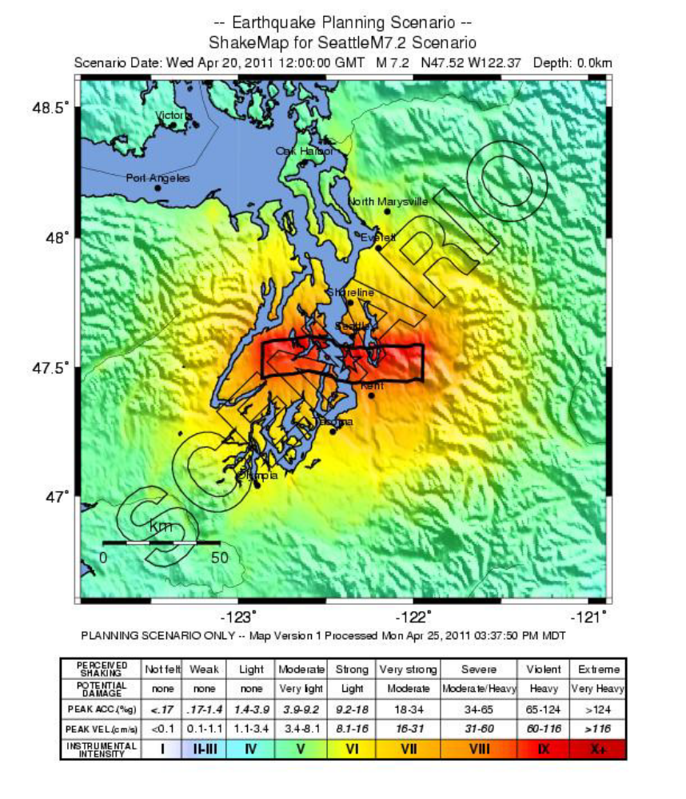
Figure 1. ShakeMap for a M7.2 earthquake on the Seattle fault zone. The black polygon is the modeled fault rupture for this scenario. (USGS, 2015)

Geologic Description
The Seattle fault earthquake scenario posits a M7.2 earthquake caused by a 63 kilometer (40 mile)-long rupture on the northernmost strand of the Seattle fault zone from the Kitsap Peninsula to just east of Lake Sammamish. The scenario is based on an earthquake that probably caused a surface rupture on the fault in the Bellevue area thousands of years ago. That event caused about 2 meters (6.5 feet) of surface displacement west of Lake Sammamish near SE 38th Street.
The Seattle fault’s location was originally determined using geophysical studies that showed a high-amplitude gravity anomaly between uplifted Tertiary volcanic rock to the south and down-dropped Tertiary and Quaternary sediments to the north. This is one of the strongest gravity anomalies in the continental U.S. Later researchers used geologic mapping and high-resolution aeromagnetic and seismic reflection data to locate several sub parallel fault strands within an east-trending zone along the gravity anomaly.
A conspicuous platform bordering the shoreline of southern Bainbridge Island, parts of Kitsap County, and Alki Point in West Seattle is the best geological evidence for a large earthquake on the Seattle fault. This intertidal wave-cut platform, cut on Oligocene Blakeley Formation and Miocene Blakely Harbor Formation, was uplifted as much as 8 meters (26 feet) in a single earthquake about 1,100 years ago. Secondary effects of this large earthquake (a tsunami, landslides, and liquefaction) are also documented. Investigation of an 8,000-year history of activity on the Seattle fault found evidence for possibly one additional earthquake on the Seattle fault about 6,900 years ago, suggesting a recurrence interval of thousands of years for large earthquakes.
Lidar (light detection and ranging) surveys found a fault scarp on southern Bainbridge Island. Subsequent trenching studies across this scarp revealed evidence for up to three surface-rupturing earthquakes in the past 2,500 years. Additional surveys and analysis of existing lidar identified potential fault scarps at several other locations within the fault zone. Trenching on scarps at Islandwood on Bainbridge Island and Waterman Point and Point Glover in Kitsap County showed evidence of possibly two surface-rupturing earthquakes about 1,100 years ago. Recent geologic mapping suggests that the Seattle fault zone extends to the Olympic Mountains on the west and the Cascades on the east.

Type of Earthquake

Most earthquake hazards result from ground shaking caused by seismic waves that radiate out from a fault when it ruptures. Seismic waves transmit the energy released by the earthquake: The bigger the quake, the larger the waves and the longer they last. Several factors affect the strength, duration, and pattern of shaking:
- The type of rock and sediment layers that the waves travel through.
- The dimensions and orientation of the fault and the characteristics of rapid slippage along it during an earthquake.
- How close the rupture is to the surface of the ground.

Deep vs. Shallow: The M7.2 scenario earth-quake modeled for the Seattle fault zone is a shallow or crustal earthquake. Shallow quakes tend to be more damaging than deep quakes of comparable magnitude (such as the deep M6.8 Nisqually earthquake in 2001). This is primarily because the seismic waves of deeper quakes have lost more energy by the time they reach the surface.
Aftershocks: Unlike deep earthquakes, which usually produce few or no aftershocks strong enough to be felt, a M7.2 shallow earthquake like the one in this scenario would likely be followed by many after-shocks, a few of which could be large enough to cause additional damage.

Other Earthquake Effects

Tsunamis: Some earthquakes may rupture a fault at the surface of the ground. If this offsets the floor of Puget Sound, it could generate a local tsunami. Delta failures and landslides caused by the shaking may also create or amplify tsunamis. Geological and historical evidence shows that landslides and failures of the sediments in river deltas have generated tsunamis within Puget Sound in the past.
Liquefaction: If sediments (loose soils consisting of silt, sand, or gravel) are water-saturated, strong shaking can disrupt the grain-to-grain contacts, causing the sediment to lose its strength. Increased pressure on the water between the grains can sometimes produce small geyser-like eruptions of water and sediment called sand blows. Sediment in this condition is liquefied and behaves as a fluid. Buildings on such soils can sink and topple, and foundations can lose strength, resulting in severe damage or structural collapse. Pipes, tanks, and other structures that are buried in liquefied soils will float upwards to the surface.
Artificial fills, tidal flats, and stream sediments are often poorly consolidated and tend to have high liquefaction potential. For example, in this scenario, the liquefaction susceptibility of the land on either side of the Green River is rated moderate to high.
Landslides: Earthquake shaking
BE PREPARED WHEREVER YOU ARE: Develop a plan and a disaster supply kit. When you’re prepared, you feel more in control and better able to keep yourself and your family safe.
LEARN MORE ABOUT WHAT YOU CAN DO: www.emd.wa.gov
may cause landslides on slopes,
particularly where the ground is
water-saturated or has been
modified (for example, by the
removal of stabilizing vegetation). Steeper slopes are most susceptible, but old, deep-seated
landslides may be reactivated, even where gradients are as low as 15%. Catastrophic debris flows can move water-saturated materials rapidly and for long distances, mostly in mountainous regions. Underwater slides are also possible, such as around river deltas.

Hazus Results for the Seattle Fault Scenario

Hazus is a nationally applicable standardized methodology developed by FEMA to help planners estimate potential losses from earthquakes. Local, state, and regional officials can use such estimates to plan risk-reduction efforts and prepare for emergency response and recovery.
Hazus was used to estimate the losses that could result from a M7.2 earthquake on the Seattle fault. Such an event is expected to impact fifteen counties in Washington, with the most significant effects apparent in King and Kitsap counties.
Injuries: The number of people injured is likely to be high, particularly if the earthquake occurs during or at the end of the business day. King County is expected to suffer the highest number of casualties (as many as 15,615), followed by Kitsap and Pierce counties; many of these injuries will require hospitalization and hundreds may be life-threatening if not treated promptly. Numerous fatalities are also likely, the highest number being in King and Kitsap counties (over 1,000 if the event occurs at 2:00 PM).
Damage: The earthquake will damage thousands of buildings in all of the affected counties. King and Kitsap counties account for the largest part of the total (357,789 and 68,094 respectively) and will suffer damage to the highest percentages of their building stocks. In many cases, damage will be slight to moderate, but large numbers of buildings will suffer extensive damage (over 21,000 in King County alone). Thousands of buildings are expected to collapse or to be in imminent danger of collapse (complete damage). Most of these are in King and Kitsap counties. The majority of damaged structures will be residential, commercial, and industrial, but the total includes buildings of all types and occupancy classes. Many unreinforced masonry and non-ductile concrete structures are likely to collapse.
Economic Losses Due to Damage: Capital stock losses are the direct economic losses associated with damage to buildings, including the cost of structural and non-structural damage, damage to contents, and loss of inventory. King and Kitsap counties account for the largest portion of the estimated capital stock loss (nearly $19 billion).
Income losses, including wage losses and loss of rental income due to damaged buildings, are also highest in King County (over $4 billion) and Kitsap County (about $597 million).
Impact on Households and Schools: The number of people without power or water is highest in King and Kitsap counties. In King, 218,464 households will have no power on Day 1; over 333,000 will have no water. King and Kitsap also account for most of the displaced households and individuals in need of shelter. The quake will seriously affect the short- and long-term functionality of schools in these counties.
Debris Removal: Following an earthquake, debris (brick, wood, concrete, and steel) must be removed and disposed of. Much of this will come from King and Kitsap counties (over 7 million tons).
Estimates vs. Actual Damage: Although this M7.2 earthquake scenario was modeled using the best scientific information available, it represents a simplified version of expected ground motions. The damage resulting from an actual earthquake of similar magnitude is likely to be even more variable and will depend on the specific characteristics and environment of each affected structure.
Other Tools: Community planners can also look at how a large earthquake is likely to impact local resources and people’s lives and livelihoods. The following graphs illustrate variations in such impacts: The first shows the levels of shaking that residents are likely to experience; the second shows the possible impact on different services and business sectors. Even where structural damage to buildings is slight, the shaking may be strong enough to damage furnishings and inventories.

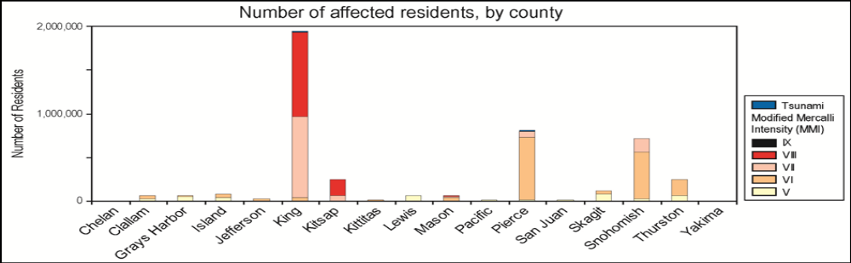

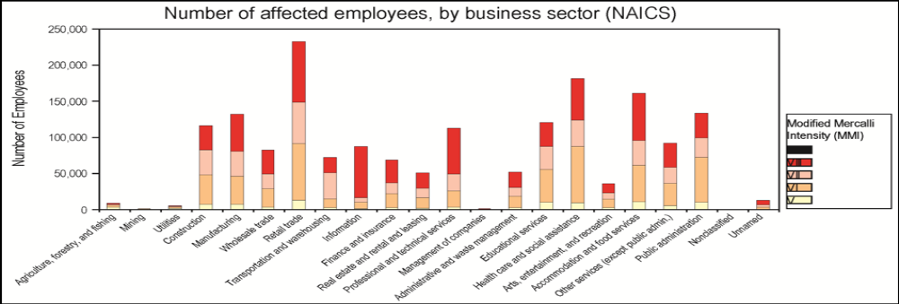Figure 2. Number of residents and employees affected by the M7.2 earthquake projected for the Seattle fault.
The Modified Mercalli Intensity (MMI) classes indicate peak ground acceleration (PGA) values and the impact of the shaking.

Appendix B: Intensity

Intensity, as opposed to Magnitude, or Moment Magnitude, is a measure of how the ground shakes as well as the effects of an earthquake. Intensity varies from site to site depending on factors such as distance from the earthquake, and rock and soil conditions. Effects of an earthquake include potential damage, perception of shaking, and permanent changes in the landscape from ground failure.

The intensity scale used most often in the United States is the Modified Mercalli Scale (MMI), which uses Roman Numerals to represent progressively greater ground shaking and damage.

Peak Ground Acceleration (PGA) is the measure of the greatest velocity of ground shaking caused by an earthquake and the force this shaking applies to buildings. These forces are expressed as a percentage of gravity (%g), with higher numbers representing progressively greater force being applied by ground motions. Many building codes describe how much horizontal force a building should be able to withstand during an earthquake.

The table below provides a comparison of damage or impacts of earthquakes of various intensities, and levels of ground shaking. Using the table, one can compare impacts of the 2001 Nisqually earthquake (peak ground accelerations reached 30 percent of gravity) with anticipated impacts of the scenario Seattle Fault earthquake (peak ground accelerations anticipated at 70 percent of gravity).

MMI PGA % g (est.) Perceived Shaking Potential Damage
IV 1.4-3.9% g Light Most people indoors feel movement. Hanging objects swing. Windows, dishes, doors rattle and glasses clink. Walls of wood frame buildings creak. Parked vehicles rock.

V 3.9-9.2% g Moderate Almost everyone feels movement. Doors swing open or close. Shutters and pictures on wall move. Sleeping people awakened. Small, unsecured objects move or topple. Liquids in containers may spill.

VI 9.2-18% g Strong Everyone feels movement. People have trouble walking. Objects fall from shelves. Pictures fall off walls. Furniture moves. Weak plaster and masonry crack. Damage slight in poorly constructed buildings. Trees and bushes shake.

VII 18-34% g Very Strong People have difficulty standing. Drivers on road feel their cars shake. Furniture may overturn and break. Loose bricks fall from buildings and masonry walls. Plaster and masonry crack. Weak chimneys break at roofline. Poorly constructed buildings badly damaged.

VIII 34-65% g Severe Drivers have trouble steering. Towers, chimneys and other tall structures may twist and fall. Houses not bolted may shift off foundations. Damage considerable in poorly constructed buildings, moderate in well-constructed buildings. Tree branches break and fall. Changes occur in flow or temperature of springs and wells. Cracks appear in wet ground and on steep slopes.

IX 65-124% g Violent Masonry structures and poorly constructed buildings seriously damaged or collapse. Houses not bolted shift off foundations. Reservoirs seriously damaged. Underground pipes break. The ground cracks. Sand craters form in some areas.

X >124% g Extreme Most buildings and their foundations destroyed. Dams and dikes seriously damaged. Large landslides occur. Water sloshes onto banks of channels, rivers, and lakes. Sand and mud shift horizontally on beaches and flat land. Railroad tracks bent.

Appendix C: Time Line

Time before event Pre-Disaster; Planning and Preparation period
Time 0 Earthquake occurs; Drop, cover and hold!
Within 7 minutes Primary, secondary and surface waves pass; first damages, deaths and injuries occur
Aftershocks begin. Small fires may have started, and need to be extinguished by resident action. Retail stores begin to close; no groceries or parts available.
Within 10 minutes First damages are found, Structures become unstable or have destructed. Occupants should have placed the “OK” or “HELP” placards in a visible location.
First injuries are identified; search begins for all residents to be accounted for. Report to the Incident Commander (IC) for assignment.
Incident Commander takes charge, establishes EOC (Command Center), and assigns available personnel to recovery tasks including triage of injured. First Aid Station established.
30 to 90 minutes Recovery teams investigate damaged structures to determine usability, and that no injured are present, and tag the building Green (OK to occupy), Yellow (Restricted use), or Red (Do Not Enter). Continue with infrastructure conditions.
Reports are provided the IC for further management and action as needed.
Tune radio for disaster information.
60 minutes to 1 day Establish communications with near neighbors offering aid/needing help (May have to walk.)
2 hours to 1 day Determine needs for shelter, toilet facilities, food, injured, deceased, and establish.
2 to 10 days Earliest possibility of outside medical aid; likely longer.
10 to 14 days Earliest possibility of resupply of food and fuel.
1 to 3months Some local roads and bridges become passable. Stores still without product.
3 months to 2+ years Recovery of some roads and bridges. Major damages will cause delays to extend more than 4 years due to excessive work and few workers, transport greatly restricted.

